报错如下：

Maven install失败

Failed to execute goal org.apache.maven.plugins:maven-compiler-plugin:3.1:compile (default-compile) on project autotest_fchtgl: Compilation failure

[ERROR] No compiler is provided in this environment. Perhaps you are running on a JRE rather than a JDK?

[ERROR] -> [Help 1]

[ERROR]

[ERROR] To see the full stack trace of the errors, re-run Maven with the -e switch.

[ERROR] Re-run Maven using the -X switch to enable full debug logging.

[ERROR]

[ERROR] For more information about the errors and possible solutions, please read the following articles:

[ERROR] [Help 1] http://cwiki.apache.org/confluence/display/MAVEN/MojoFailureException

解决方案如下：

1、确认 eclipse  windows--preferences--java--installed JREs 指定的是JDK安装路径，如果原来为JRE，需修改为JDK

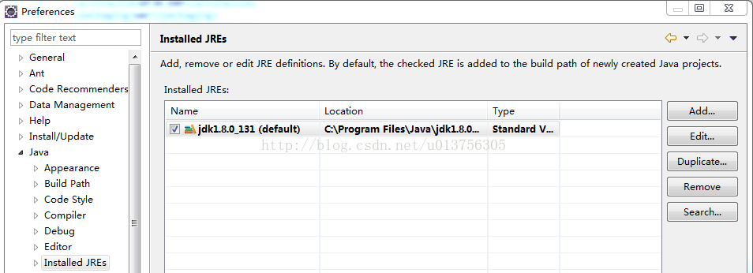

2、确认 eclipse windows--perferences--java--installed JREs--execution environments

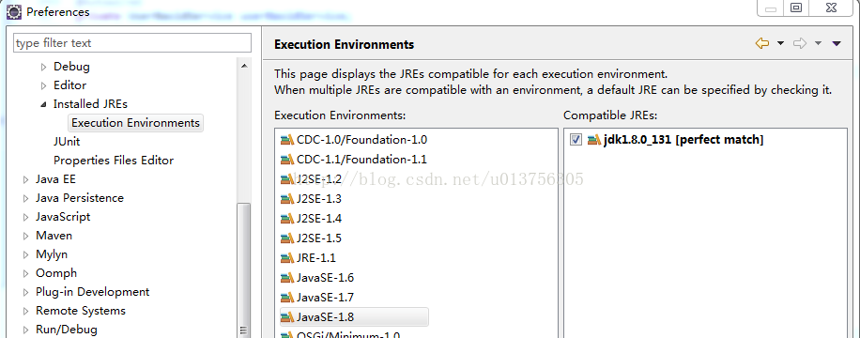

3、项目 右键 --properties  --  java build path -- libraries  -- jre system library [javaSE-1.8]  双击  -- execution environment: 选项如下图所示

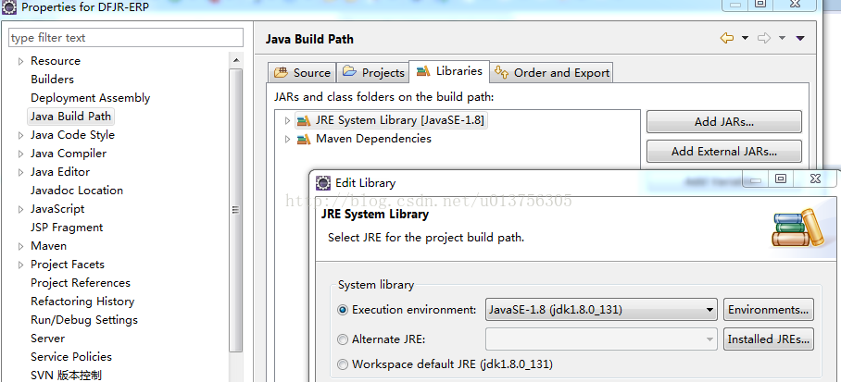

4、项目 --右键  --  run as  -- run confiurations  -- maven build  --  (选择新建的配置 ) --  JRE  --  ALTERNATE JRE: 如下所示

